LAB EXPERIMENT RECORD

Set 11: Product Category Analysis

Field | Details
Department | AIML
Course Code / Course Name | DSA0602/ Data Handling and Visualization
Experiment | Data Visualization using R and Tableau
Name | S.Naveen Kumar
Register Number | 192425176
Date | 06 October 2026
Day | Tuesday

Aim

To analyse product category sales using a funnel chart, a data table and a pie chart in R, and to build an interactive dashboard that combines them.
Dataset: Product Categories

Category | Sales (in $)
Electronics | 50000
Clothing | 35000
Appliances | 40000

PROGRAM 1: Funnel Chart of Sales

Generate a funnel chart to analyze the sales conversion process for each product category. Label the stages and title the chart.
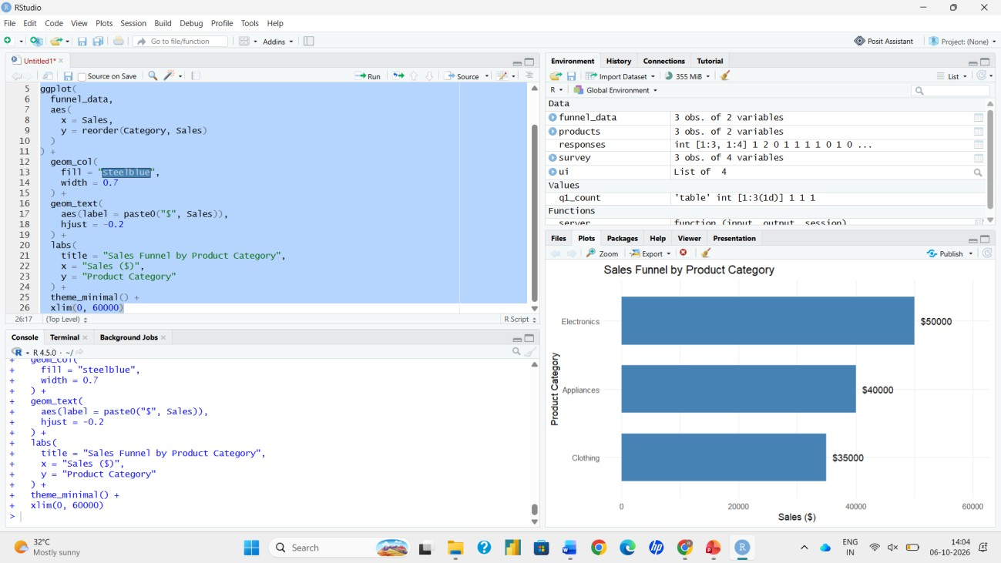
library(plotly)

# Dataset (sorted from highest to lowest sales) funnel_data <- data.frame(
Category = c("Electronics", "Appliances", "Clothing"), Sales = c(50000, 40000, 35000)
)

# Funnel Chart plot_ly(funnel_data,
type = "funnel", y = ~Category,
x = ~Sales,
textinfo = "value+percent initial") %>% layout(title = "Sales Funnel by Product Category",
yaxis = list(title = "Stage (Product Category)"), xaxis = list(title = "Sales ($)"))

Output 1: Sales Funnel Chart

PROGRAM 2: Product Sales Table

Build a table to display the sales data for each product category. Label the table elements.
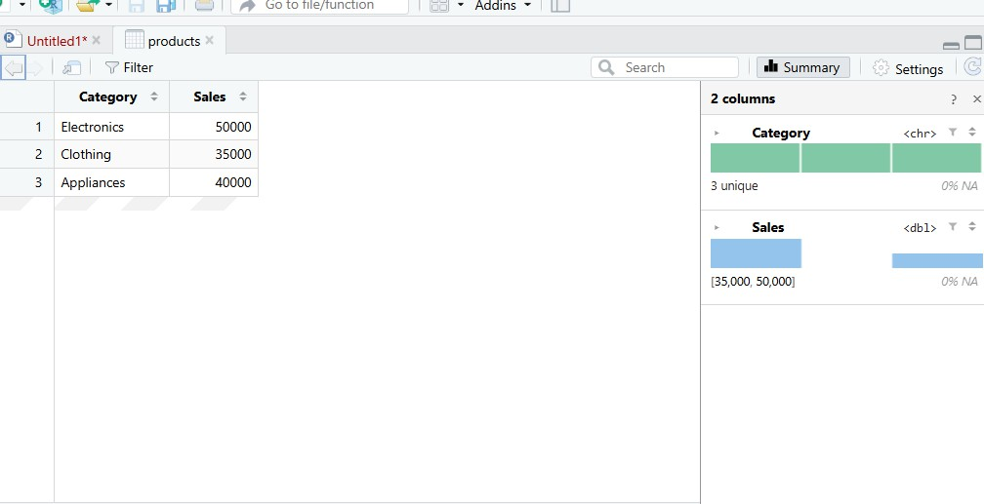
sales_data <- data.frame(
Category = c("Electronics", "Clothing", "Appliances"), Sales = c(50000, 35000, 40000)
)
colnames(sales_data) <- c("Category", "Sales (in $)") print(sales_data)
View(sales_data)

Output 2: Product Category Sales Table

PROGRAM 3: Pie Chart of Sales Distribution

Create a pie chart to represent the distribution of sales across product categories. Include labels.
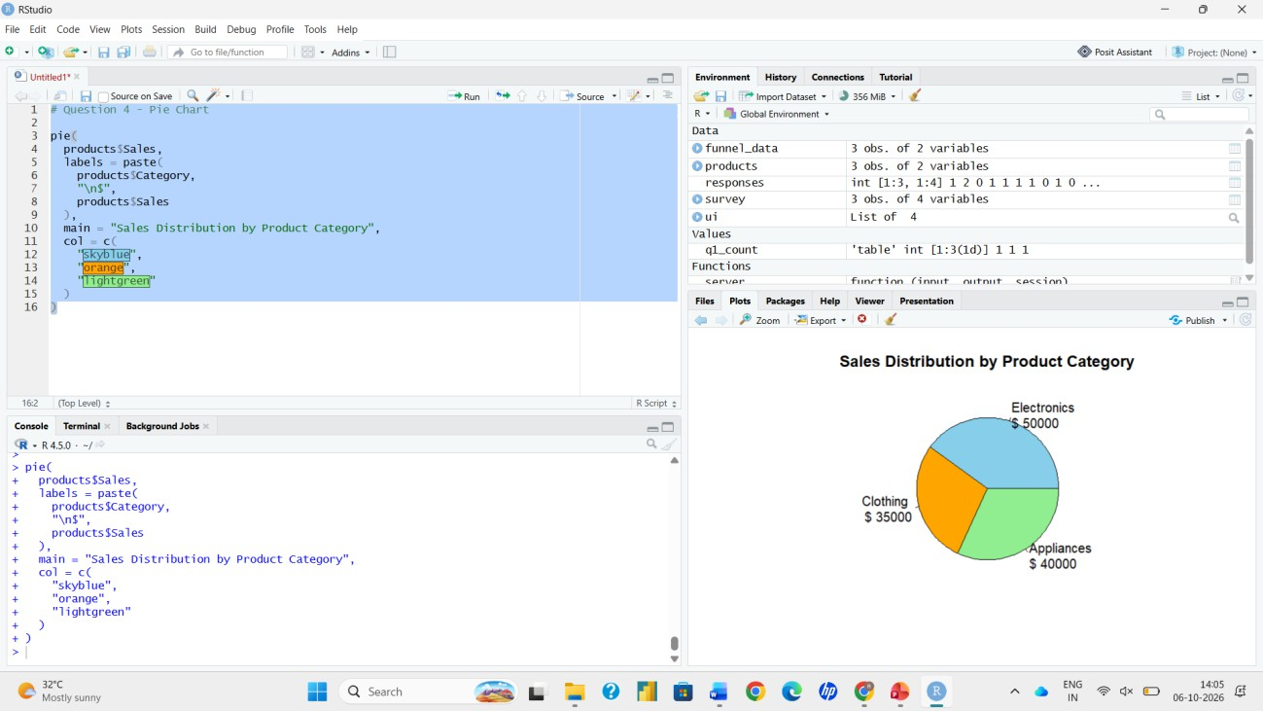
category <- c("Electronics", "Clothing", "Appliances") sales <- c(50000, 35000, 40000)

# Percentage labels
pct <- round(sales / sum(sales) * 100, 1) labels <- paste0(category, " (", pct, "%)")

# Pie Chart pie(sales,
labels = labels,
col = c("steelblue", "orange", "seagreen"),
main = "Distribution of Sales Across Product Categories")

Output 3: Sales Distribution Pie Chart

PROGRAM 4: Interactive Shiny Dashboard

Build an interactive dashboard combining the pie chart, funnel chart and the table using the Shiny package.
library(shiny) library(plotly)

sales_data <- data.frame(
Category = c("Electronics", "Clothing", "Appliances"), Sales = c(50000, 35000, 40000)
)

ui <- fluidPage(
titlePanel("Product Category Dashboard"), sidebarLayout(
sidebarPanel(
checkboxGroupInput("cat", "Select Categories:",
choices = sales_data$Category, selected = sales_data$Category)
),
mainPanel( plotOutput("pie"), plotlyOutput("funnel"), tableOutput("tbl")
)
)
)

server <- function(input, output) { filtered <- reactive({
d <- sales_data[sales_data$Category %in% input$cat, ] d[order(-d$Sales), ]
})
output$pie <- renderPlot({ d <- filtered()
pct <- round(d$Sales / sum(d$Sales) * 100, 1)
pie(d$Sales, labels = paste0(d$Category, " (", pct, "%)"), col = c("steelblue", "orange", "seagreen")[1:nrow(d)], main = "Distribution of Sales Across Product Categories")
})
output$funnel <- renderPlotly({ d <- filtered()
plot_ly(d, type = "funnel", y = ~Category, x = ~Sales, textinfo = "value+percent initial") %>%
layout(title = "Sales Funnel by Product Category",
yaxis = list(title = "Stage (Product Category)"), xaxis = list(title = "Sales ($)"))
})
output$tbl <- renderTable({ d <- filtered()
colnames(d) <- c("Category", "Sales (in $)") d
})
}

shinyApp(ui = ui, server = server)

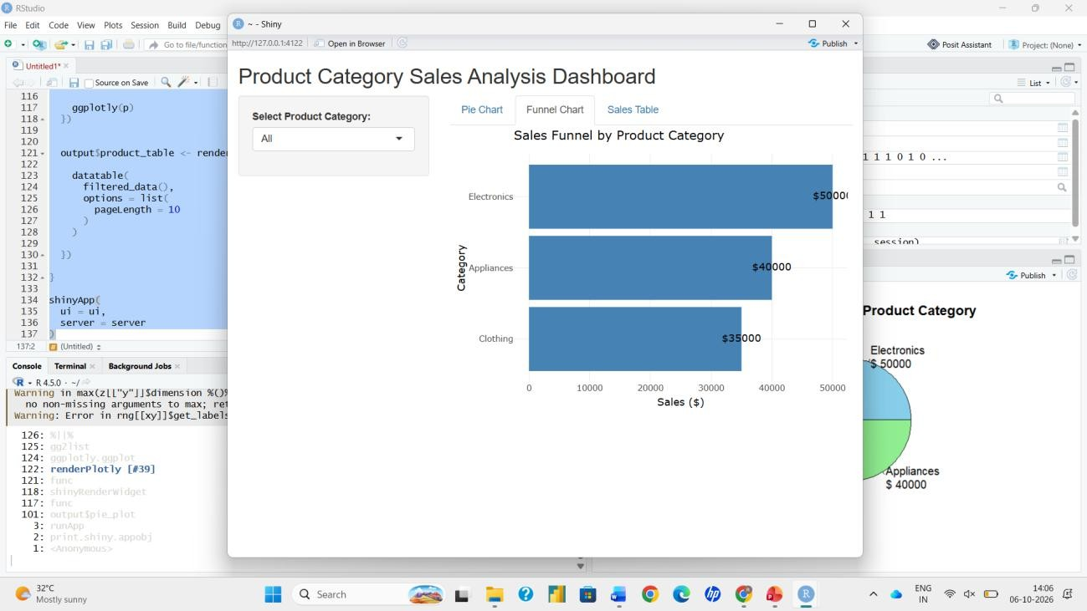
Output 4: Interactive Dashboard

